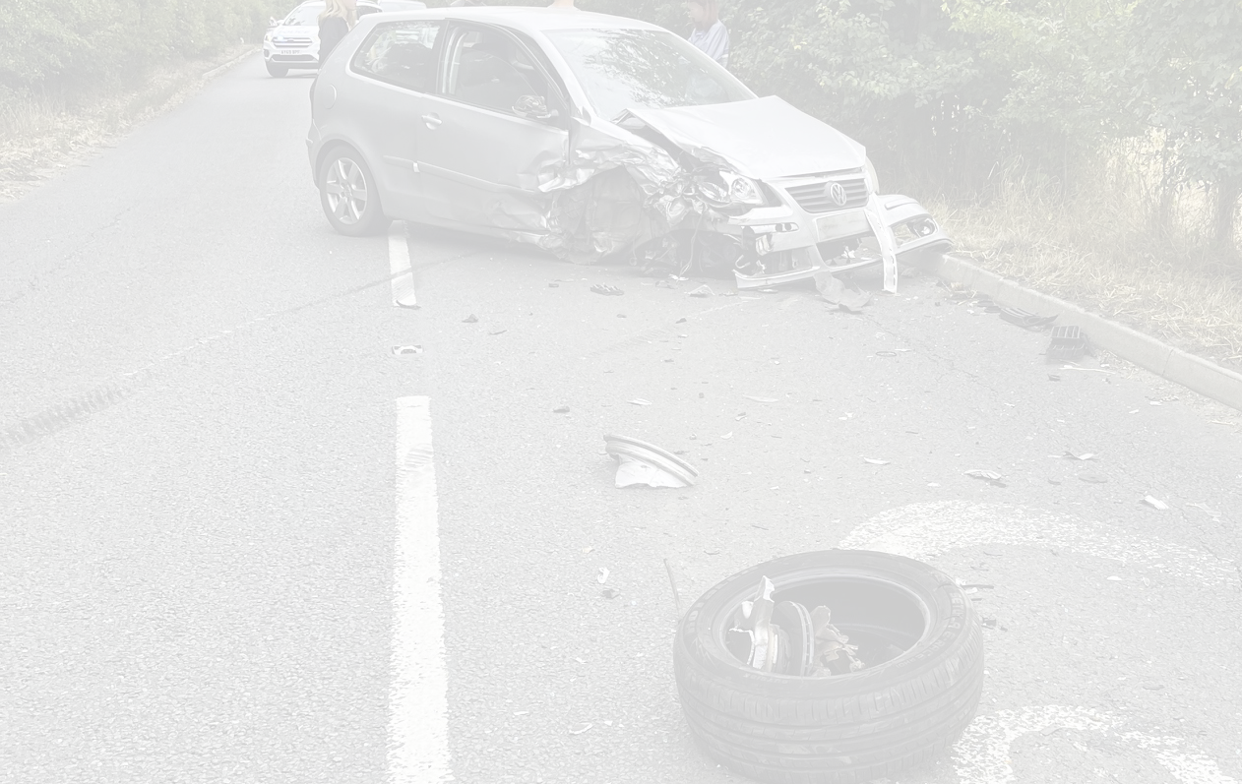

HOXNE TRAFFIC MANAGEMENT PROPOSAL 2024

Contents

SUMMARY 3
PROPOSED SPEED LIMIT CHANGES – HOXNE PARISH COUNCIL 5
TRAFFIC ISSUES 6
HOXNE PARISH 7
SPEED DATA 8
SUFFOLK COUNTY COUNCIL POLICY CONTEXT 9
COLLISION DATA 22
CRASHMAP 2012 - 2022 23
SUFFOLK CONSTABULARY FOI MAP 2012 -2024 24
ADDITIONAL COLLISIONS 2024 NOT RECORDED - HOXNE PARISH COUNCIL 25
CONSULTATION PROCESS 27
SUFFOLK CONSTABULARY EMAIL REGARDING SPEED WATCH 28
ADRIAN RAMSAY MP - SUPPORT EMAIL 29

SUMMARY

Hoxne Parish Council has prepared this Hoxne Traffic Management Proposal which addresses ongoing concerns from local parishioners about the impact of traffic speed and volume on their safety and their ability to access and enjoy local facilities in the village.
Proposals have drawn on:
- Stakeholder feedback – residents, the primary school, The Depperhaugh Care Home, St Peter and St Paul’s Church and local businesses.
- Speed data from radar and strip monitoring and collision data from Crashmap, Suffolk Constabulary and local reporting.
- Long term discussions with District and County Councillors.
- Suffolk County Council Highways and their Speed Limit policies.
- Site meeting and on-going liaison with the Police and Crime Commissioner and the Assistant Chief Constable.

The proposals are as follows:
B1118/Green Street
- Speed limits
  - To extend the 30 mph limit eastward to the Old Police House.
  - To introduce a 40 mph buffer limit further east to the concrete beet pad.
  - To introduce an advisory 20 mph limit to the west end of the road at the junction with Low Street.

- Signage and Road Markings
  - To introduce double white lines at the eastern approach to the village at Wittons Lane/Syleham Road bends and at the bend at Moat House and Orchard Cottage.
  - To improve warning signage at bends at Chickering and Oakley.

Low Street
- Speed limits
  - To introduce a 20 mph limit from the junction with Green Street to the south of the bridge at the Swan Inn.

Eye Road
- Speed limits
  - To extend the 30 mph limit towards Eye to beyond Home Farm.

Cross Street
- Speed limits
  - To introduce a 20 mph limit from Abbey Farm to Heckfield Green.

Nuttery Vale
- Speed limits
  - To introduce a 20 mph limit up to existing National Speed limit sign.

Heckfield Green
- Speed Limits
  - To introduce 20 mph limits up to National Speed Limit signs on all roads around the junction at the primary school – Denham Road, Wittons Lane, Denham Low Road and Chickering Road. Run the 20 mph limit through Cross Street.

Once the proposals are accepted by the County Council and other statutory consultees, Hoxne Parish Council will be responsible body for preparing an implementation plan and presenting funding options to residents. This document will demonstrate why these changes are required to support the safety of residents, visitors and those travelling through the village and to facilitate on going deployment of SID devices and to enable effective policing and enforcement.
Hoxne Parish Council has considered the implementation of a Community Speed Watch scheme but concluded there are significant concerns about safety and abuse. On 22 August 2024 communication was received from Guy Ainsworth – Suffolk Constabulary Speed Watch Manager – who stated, “after driving the roads mentioned I could not find a safe suitable position within our strict safety guidelines to set-up and monitor speeds”. The email is attached at the end of the document.
The proposal is supported by Adrian Ramsay MP, whose email is also attached at the end of the document.

PROPOSED SPEED LIMIT CHANGES – HOXNE PARISH COUNCIL

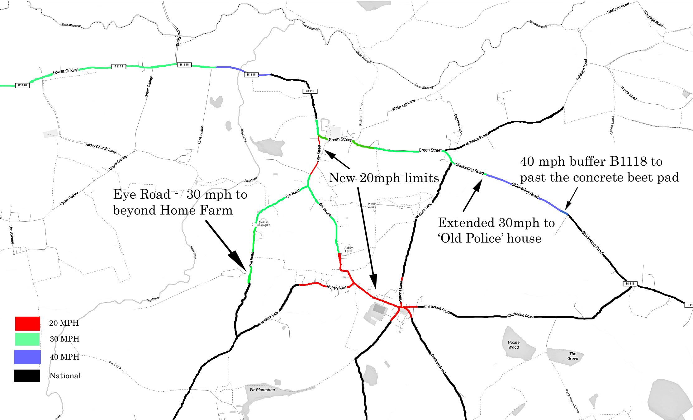

TRAFFIC ISSUES

Following a Community Infrastructure Levy survey undertaken by the Parish Council, traffic issues were identified as the priority amongst residents. The Parish Council has since carried out further consultations with residents at several events and locations where the issue was explored in more detail.
This report aims to improve the safety and quality of life of all its residents by using a whole parish approach.
Speed - The overarching factor in all proposed changes to the speed limits is to reduce the number of collisions that occur and the severity of those that do. Pedestrians and other road users will feel safer and the quality of life for the residents will be improved.
HGVs – Whilst all the following groups are affected by this class of vehicle specific mention must be given to the considerable impact they create within the parish. None of the roads they travel on are suitable for the volume that occurs daily, but some of the unclassified roads put 44 ton HGVs into direct contact with all the groups below due to the lack of footways, road width and building construction. At harvest time this traffic can be increased significantly together with many tractor and trailer movements day and night.
The Parish Council cannot affect HGVs using the village, but it seeks to minimise their impact by reducing speeds where they travel. Allowing a consistent low speed approach through the village will help mitigate their impact.
Residents – Safety is the prime concern for residents. There is a primary school on Cross Street, situated on a multiple road junction that unfortunately does not have a footway around the whole of its perimeter facing the road. Many of the roads in the village do not have footways but residents must use these daily and reductions in speed in these areas will reduce the potential for any serious casualties. Traffic impacts also on the quality of life of residents from vehicle vibration, HGV incursions onto property, engine noise issues when accelerating from one speed limit to another. Many residents are first on scene of the numerous injury collisions that have occurred rendering aid where necessary but also witnessing the trauma involved.
Pedestrians – The B1118 also carries the Mid Suffolk footpath for part of its length before this footpath turns down into Low Street and through to the Eye Road. Two of the villages access roads have been designated Quiet Lanes, illustrating the wide variety of uses the roads in and around Hoxne have. The lack of footways at several sites leaves people vulnerable to traffic.
Cyclists – National Cycle Route 30 also traverses through much of the village, including the B1118, Low Street, Cross Street and Nuttery Vale. Due to the deteriorating road surface cyclists are forced further towards the centre of the road along the B1118 where most traffic is present.

HOXNE PARISH

Hoxne is situated in the north of the County of Suffolk near the Waveney Valley and is a small to medium-sized village of some 850 residents. It is a rare surviving poly-focal settlement, with both parts of the village having designated conservation areas to reflect their architectural heritage or historical connections. Outlying areas such as Chickering complete the makeup of the parish.
Despite its size, the parish has many routes through which traffic travels. Two of those access routes are either end of the B1118, which, despite being a secondary road, has been designated a lorry route and, therefore, shoulders a high proportion of heavy goods vehicles.
Low Street, Cross Street and the Heckfield Green area do not even include any secondary roads. They have houses on both sides for all their length and for most of the day carry a high volume of HGVs making their way to an animal feed production and milling facility which is situated towards Denham but still within the parish. On leaving, many of these HGVs will travel along Chickering Road, which is a single-track road, before rejoining the B1118 at the Depperhaugh Care Home.
Hoxne is highly valued for its qualities as generally a quiet village with a strong community spirit enhanced by its wealth of historical connections and architectural heritage. It is therefore not just valued by residents for these qualities, but also by the large number of visitors too.
The document captures the complexity of the road system in Hoxne and presents the proposed changes to speed limits, signage and road markings across the village. Each road has been taken in some level of isolation as each road has different requirements and a blanket 20 mph everywhere would not be supported if proposed.
By looking at each road individually, we believe that we can get the best outcome for the parish as a whole. Extending the limits rather than changing them in some cases will make more sense to road users in general. Improved road markings and signage will be imperative where speed limits will not be changed. With an extension of certain speed limits, the Parish Council will be able to safely deploy Speed Indication Devices more effectively going forward to encourage drivers to comply.

SPEED DATA

The speed data was obtained directly from Suffolk Highways who placed radar and strips in several locations around the parish and from which the following graphs have been compiled. They cover both mean and 85th percentile figures for each location to give as much information for the decision making process as possible.
The Parish Council sought to get further data for Cross Street and Heckfield Green but were advised by Councillor Hicks not to at present.
Hoxne Parish Council also collects its own data from a SID device that is placed at three locations around the village which can provide further reference to areas not covered by the placed strips/radar e.g. Abbey Hill.
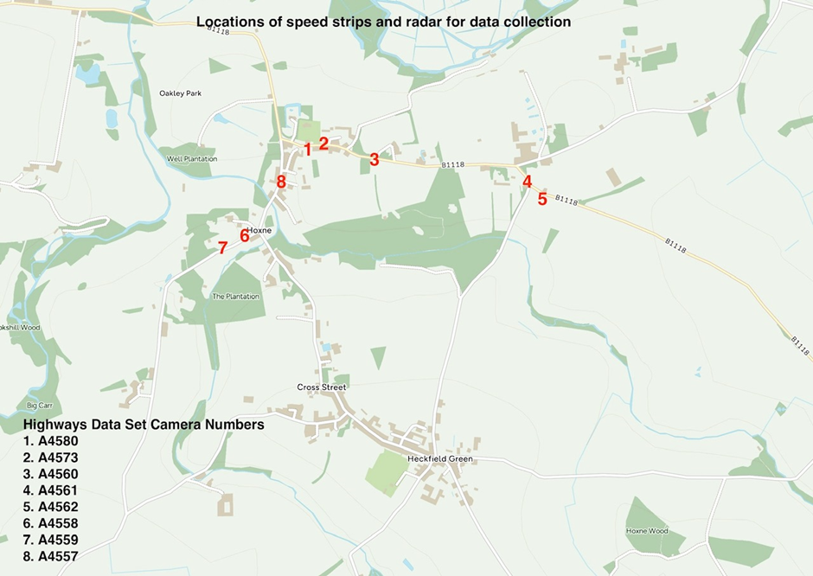

SUFFOLK COUNTY COUNCIL POLICY CONTEXT

B1118 / GREEN STREET

The B1118 is a 2.5 mile main route running from the outskirts of Oakley through Hoxne to Chickering with up to 5200 weekday vehicle movements at the Low Street junction representing more than 80% of the total movements in Hoxne. It is a complex road presenting differing challenges along its length for all road users and its residents. The collision history of the B1118/Green Street is the most significant in the parish and runs the entire length as noted on the maps below.
There are many stretches of this road that present hazards due to the nature of the highway, the classes of vehicles using it, the proximity of vulnerable road users and pedestrians to traffic and the condition of the carriageway surface itself.
The key features of the road and SCC applicable criteria are detailed below:
SCC Policy 30 mph criteria –
S21. Collision history, adverse environment impact, National cycle route 30, consistent approach.
SCC Policy 40 mph criteria –
S19. Collision history including fatal RTC, accesses including farm pads, existing traffic speeds 40/45 mph.

A section of Green Street runs through a conservation area where St Peter and St Pauls’ Church is located and National Cycle Route 30 runs 0.75 miles from the junction at Low Street through to Syleham Road. The Mid Suffolk Footpath and the Hoxne Heritage Walk crosses the Syleham Road / Wittons Lane junction and again at Water Mill Lane with limited visibility when crossing at either point. Both pedestrians and other road users must rely on sound to warn of approaching vehicles at these and many other locations including the church due to poor visibility.
There are many bends that cause concern along this route where several issues arise.
From the Oakley bend down to the Low Street junction there have been several collisions, and this area has been advised to us as not being able to have its speed limit changed. We believe however that if the Oakley 40 mph limit just continued to the Hoxne 30 mph risk would be significantly reduced. If the case is not accepted improved signage and markings would therefore need to be considered when addressing this section. The Low Street junction has seen several agricultural trailers overturn and an advisory 20 mph max warning we believe could improve this hazard. It is accepted that there are many signs but perhaps an improved marking scheme could be considered.
As you pass the build out in an easterly direction within the 30 mph limit vehicles accelerate and then overtake on a slight bend between Orchard Cottage and Moat House before reaching the National Speed Limit sign. This is the site of several serious collisions and consideration for double white lines along this stretch would focus driver attention. The Parish Council cannot safely place the SID device at this location due to the dangerous nature of the road. The following straight section is where vehicles accelerate before braking for the Syleham Road S bend, thus causing excessive noise that carries some distance. The bend itself incorporates junctions left to Syleham and right to Wittons Lane plus a new access road to recently constructed dwellings. Visibility turning onto Green Street from Syleham Road is poor in both directions as is visibility turning into Syleham Rd from Green Street travelling west, it is the scene of many collisions over the years predominantly with vehicles traveling at speed into the junction from the Stradbroke direction. Again, consideration of double white lines through the bend may improve driver awareness. From this point on towards Stradbroke, vehicles accelerate. A fatal collision recently at a hidden concrete beet pad used frequently as a rest area demonstrates that the road speed needs to be addressed.
A continuation of the 30 mph limit from its current end point up to and beyond the bend would create a controlled acceleration and braking environment which then leads into a 40 mph buffer limit that reduces acceleration towards the concrete beet pad and slow vehicles travelling westwards approaching the S bend.
The Depperhaugh junction has been the subject of a previous review where speed limit change was considered unnecessary, however again these dangerous bends have many collisions reported. Signage is inadequate when travelling from Hoxne and markings are not visible on a degraded road surface due to wear. HGV’s exiting the Chickering Road junction pull directly onto a 60 mph speed limit where the view of traffic travelling west is obscured. We believe an improved signage and marking scheme would assist.
The speed data below selects three points on the B1118.
A4560 was located at the build out and is selected to show the increased speed when travelling to the east. The average speeds marked do not fully show the excess speeds that the main data set contains. A five day average of over 150 vehicles a day continue at over 35 mph through the 30 mph limit towards the National Speed Limit.
Mean and 85th percentile speeds at location A4561 are mainly recorded below 30 mph.
At location A4562 mean speeds were measured between 40 & 46 mph depending on direction.

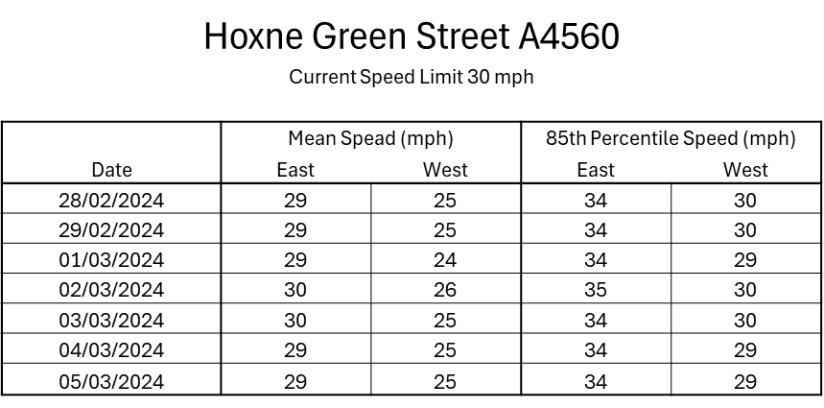

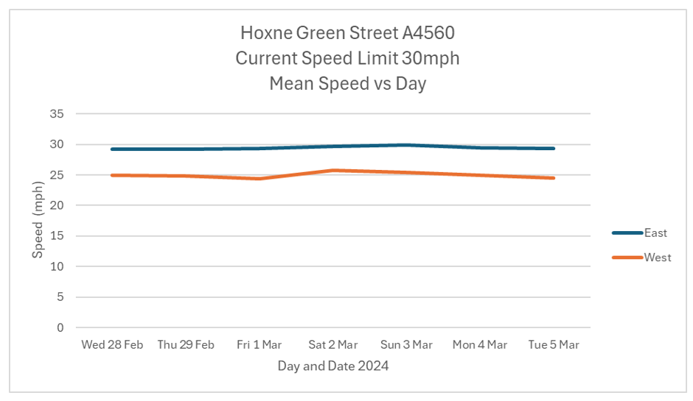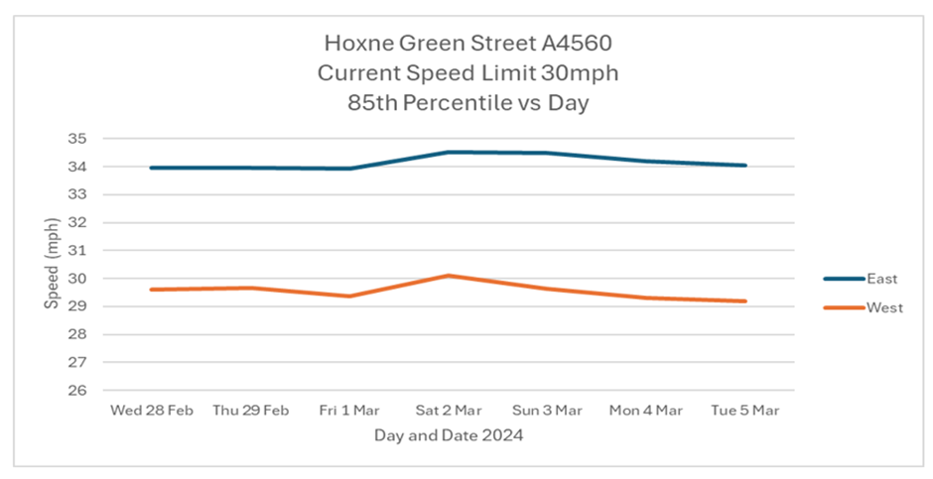

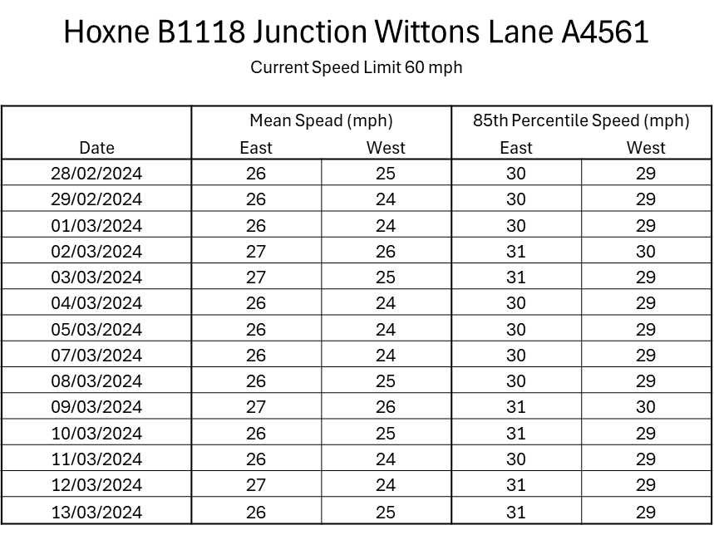
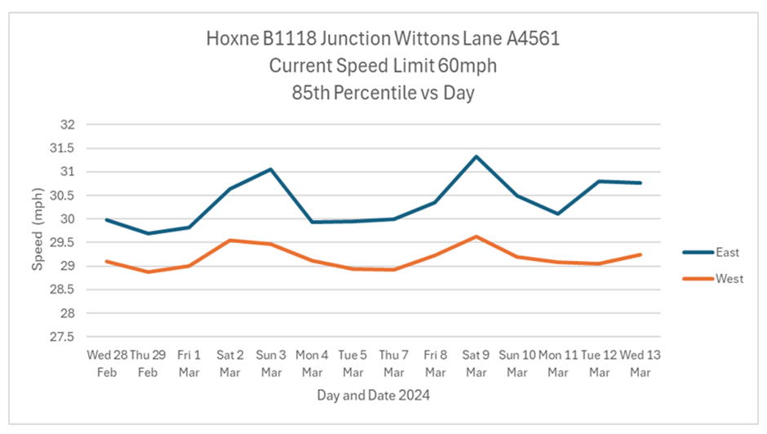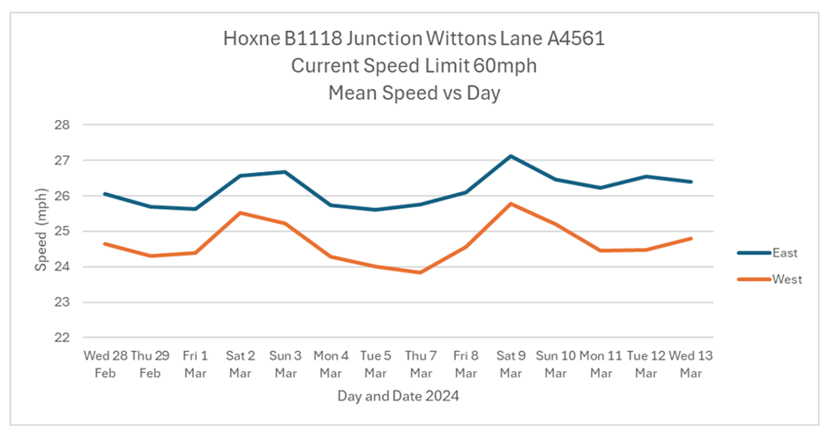
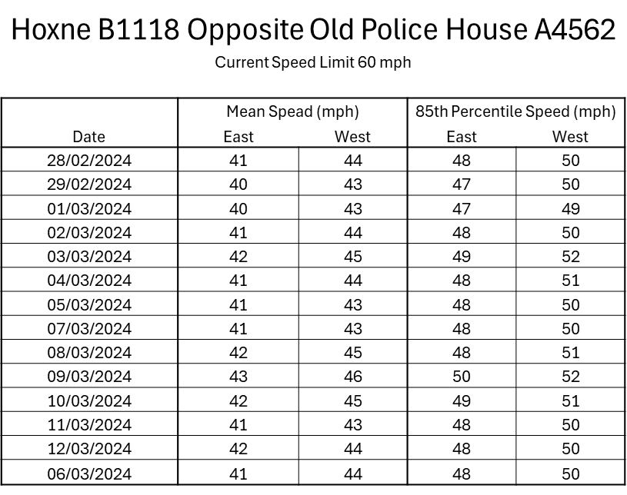
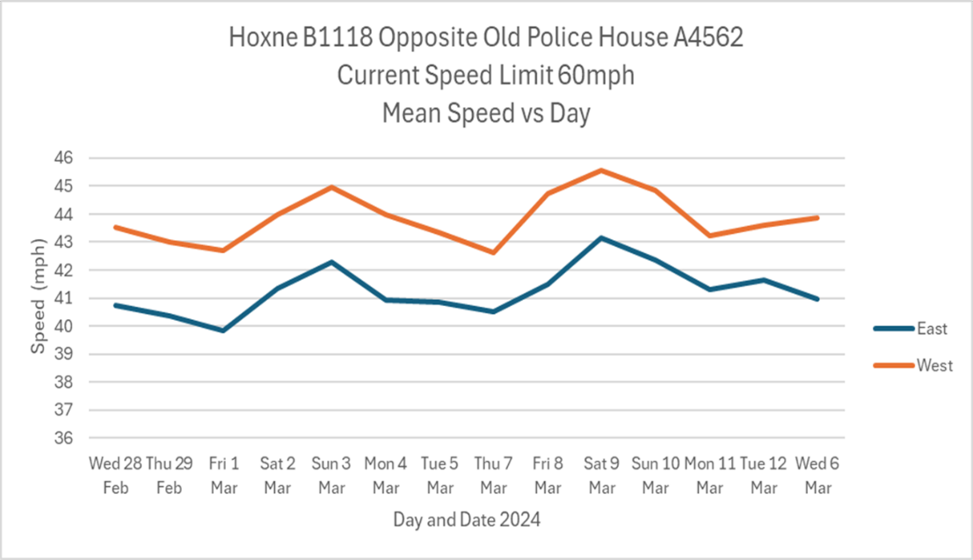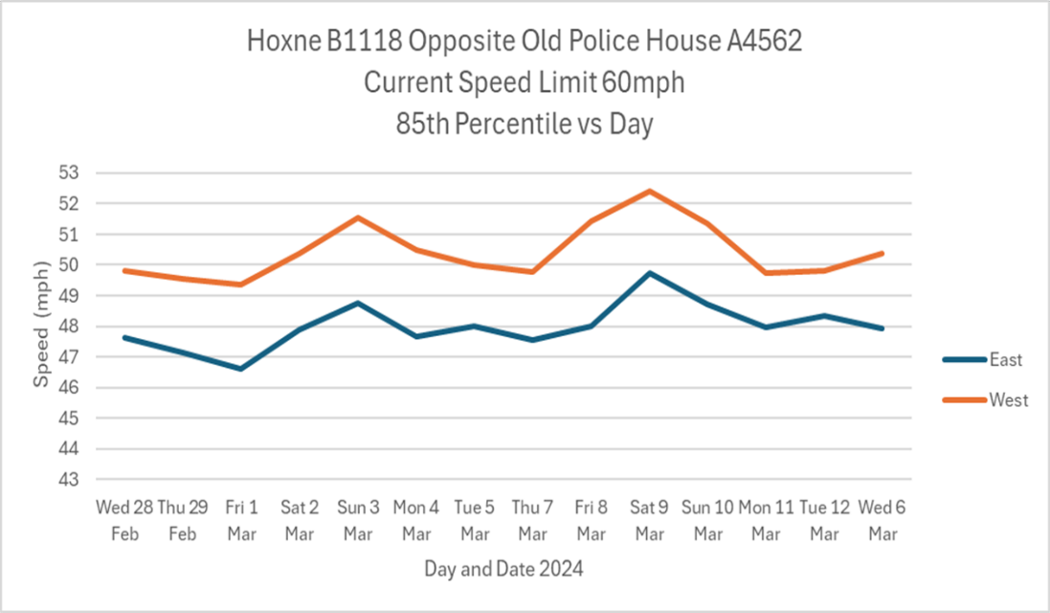

LOW STREET

The top end of Low Street forms a junction with the B1118 (Green Street). At this point, Green Street is a sharp bend with Low Street radiating from it. Down to the village centre there are no footways and the road narrows with parked cars grouped on either side of the road initially on the nearside then by the village green on the offside.
The small village green runs along the nearside of the road and incorporates a pedestrian path from the end of Church Hill (Hillside) to almost the village shop. The only other stretch of footway now begins on the opposite side of Low Street, running parallel to the village green. The village green is regularly used for village-wide events such as the Harvest Breakfast or by groups of tourists, walkers, or cyclists as again this is part of National Cycle Route 30.
Many of the dwellings along Low Street are late medieval in date. They are timber-framed with minimal foundations and so susceptible to vibrations from many larger vehicles using this route seven days a week. This area is part of one of the village conservation areas.
Low Street contains the village shop and post office, with no more than four parking spaces in front of them. The village pub, The Swan is on the opposite side of the road and there is a constant flow of pedestrians on the road when these facilities are open. No footway exists outside the village shop or the pub. Through the bottom half of the village, Low Street, is an unclassified road with dwellings on either side of it with very little or no front garden and, therefore, front onto the road. After the Swan, continuing south, Low Street narrows at the bridge to cross the Goldbrook river.

SCC Policy 20 mph criteria –
3.2 Not A or B road, existing mean speed 21/22 mph, County and District Councillor Support, conservation area
3.3 Mean speed below 24 mph, Shop and pub pedestrian movement, National cycle route 30

The request for a 20 mph limit reflects the fact that the focal part of the village is not an A or B road but is an HGV route with footways absent at some key points. This combines with the fact the road is in a conservation area with a low mean speed with considerable local and tourist pedestrian and road user movement.
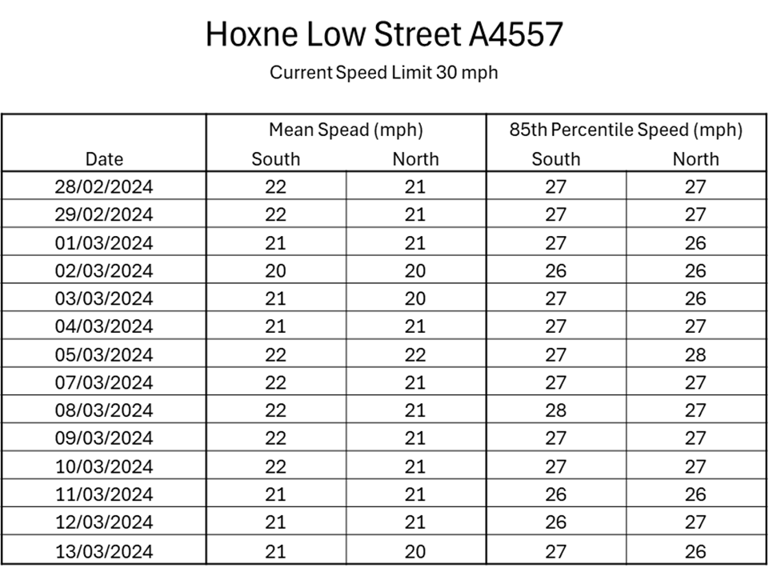

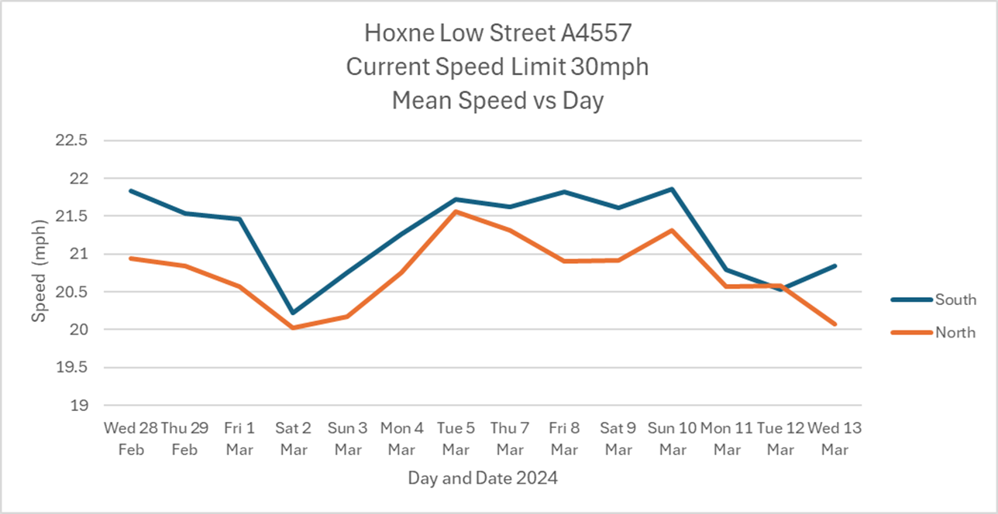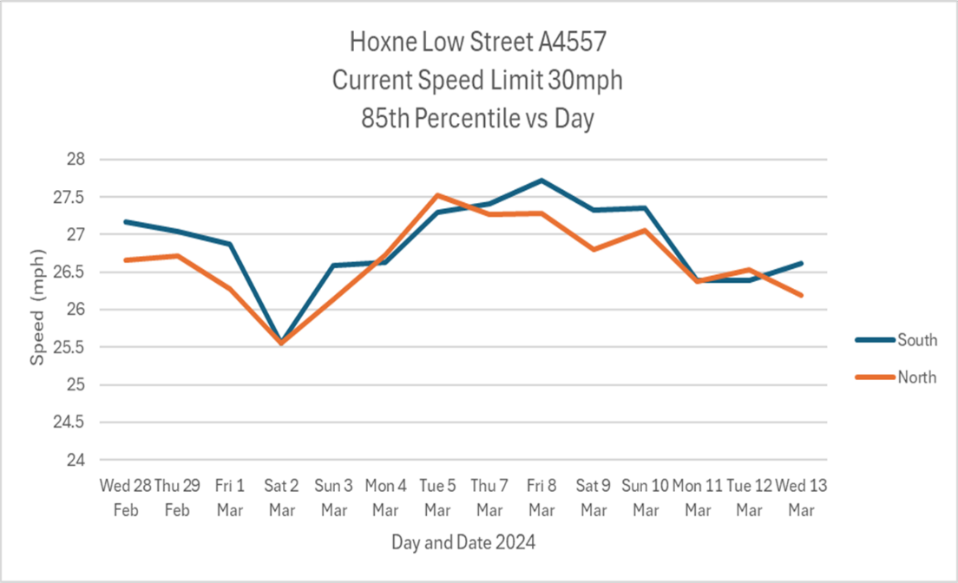

EYE ROAD

The Eye Road continues from Low Street and has no footway, the NSL sign is positioned at the very beginning of the road out of the village, with some fifteen houses along the road beyond this point. The road is a narrow, single-track road in many places, and has no official passing spaces all the way out to Nuttery Vale. Eye Road is heavily used for walking, cycling and horse-riding and is used by HGV’s and agricultural vehicles frequently.
SCC Policy 30 mph criteria –
S21. Consistent approach, promote walking route, no extra signing or marking appears suitable, existing mean speeds of 35 mph.
Seeking an extension to the 30 mph reinforces the need for a consistent approach when reducing speeds towards the village itself. There are no footways on this road and the local footpath to Eye is within the National Speed Limit section of the road. Means speeds average around 35 mph in both directions within the 60 mph section.
The delayed start to the existing 30 mph limit, gives drivers too little time to adapt to driving within a village environment. Conversely, when exiting the existing 30 mph limit, drivers are given the false impression that the risks associated within a 30 mph area are no longer present, when they are, e.g. pedestrians on the roadway and numerous driveways.

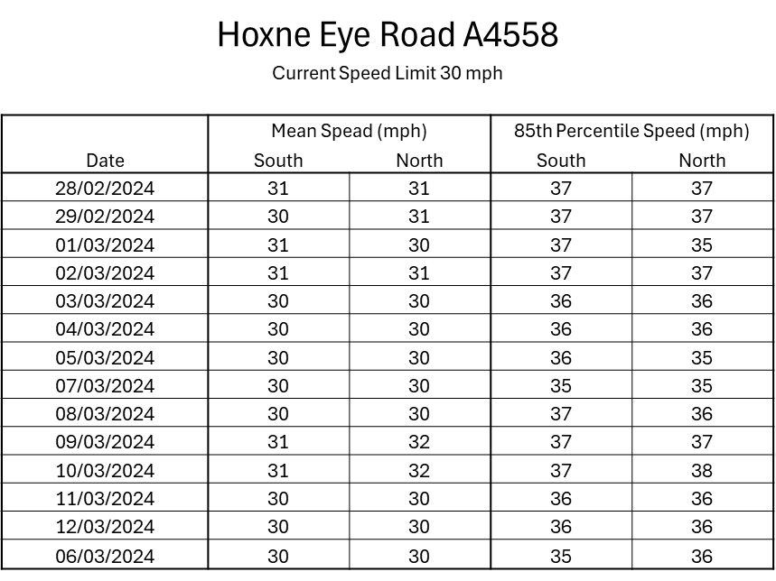

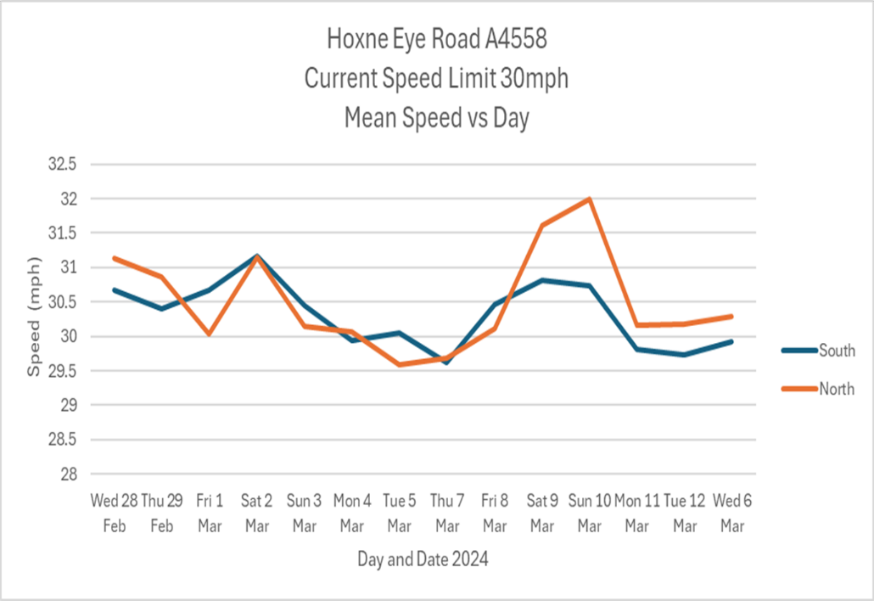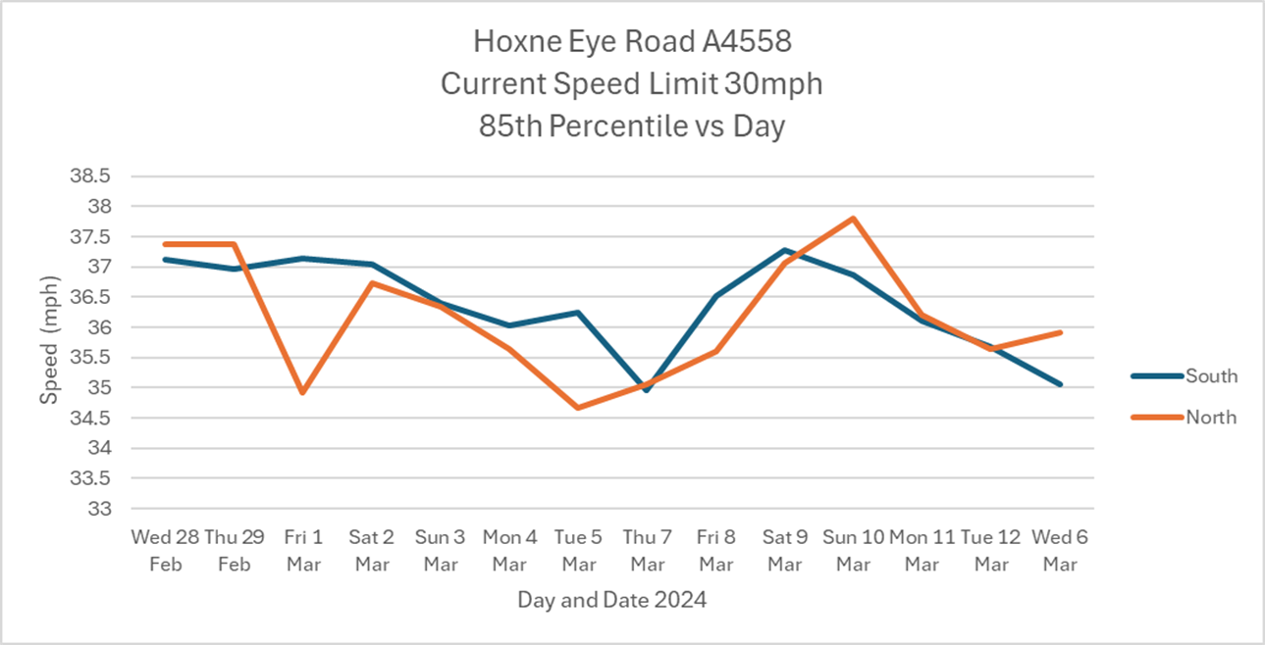

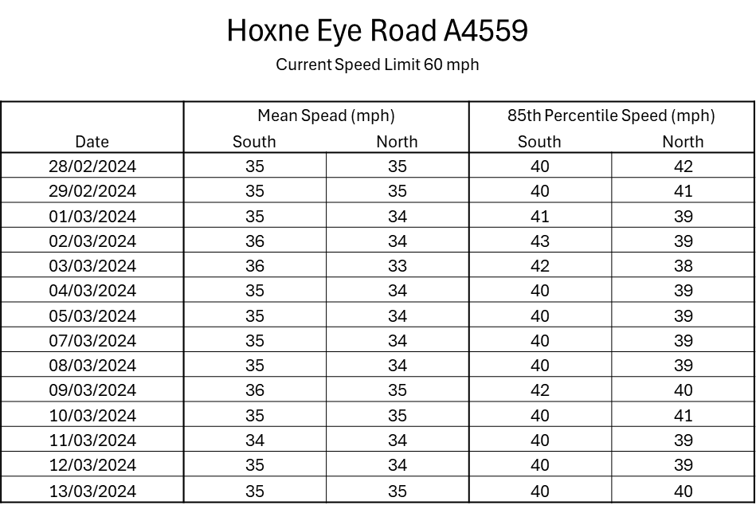
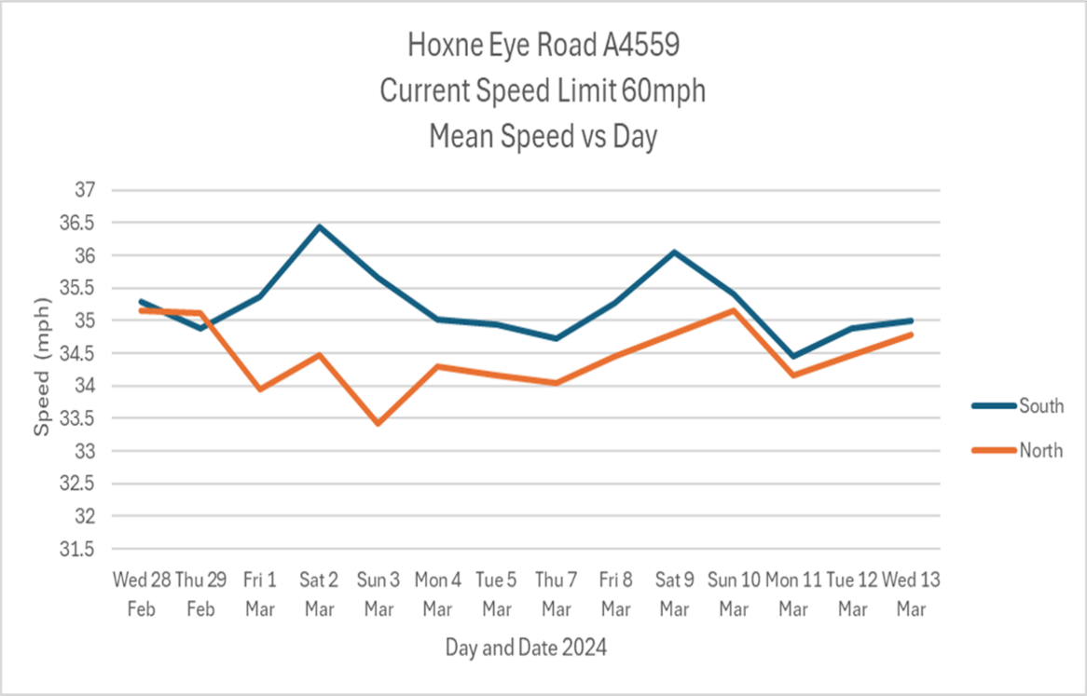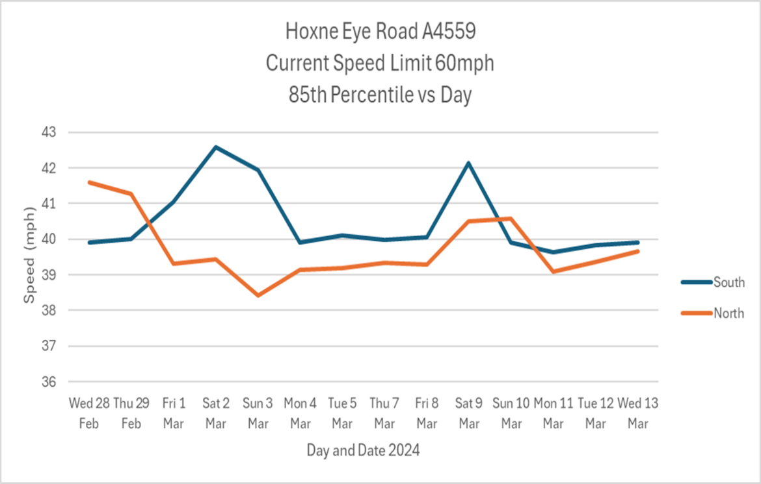

CROSS STREET/ABBEY HILL

Cross Street begins at the top of Abbey Hill at a sharp S bend, where Red Lion Close joins from the right. The footway which runs along from Goldbrook and up Abbey Hill, ends just before this bend.
The second conservation area now begins at the S bend and is not wide enough to allow two cars to pass and pedestrians must walk in the roadway. This road is supposed to be used as the one way in for 44 ton HGVs on their route in towards Crown Milling but occasionally HGV’s travelling in both directions have met at this bend. Footpaths emanate from this bend and are in daily use by residents.
Cross Street continues without a footway and is lined with older houses with poor foundations if any. Cars are normally parked along the length of this section. National Cycle Route 30 continues along Cross Street down to the junction with Nuttery Vale. A school bus service uses this junction within term times to collect and deposit students.
A footway starts again on the right, just before access to another footpath. Cars parked outside terraced cottages where the second conservation area ends.
Cross Street is flanked by mixed housing until it ends at Heckfield Green with a pedestrian access to the Playing Fields on the right. The mixed housing here includes some on smaller side roads and at St Edmund’s House, where the properties are predominantly occupied by senior citizens.
SCC Policy 20 mph criteria –
Not A or B road, County and District Councillor Support, told to submit without speed data even though offered to request, National Cycle Route 30, footpath, school bus stop, conservation area, depth of residential development.
Safety issue concerns revolve around the lack of footways where pedestrians and cyclists interact with HGV’s and other vehicles on narrow sections of the road. Parked cars in the conservation area generally reduce speeds but also block views whilst narrowing the road at points where pedestrians need to walk. Access to the school and the playing field is gained from this road. There is a mix of vulnerable pedestrians in the area from children going to school and senior citizens in sheltered housing

NUTTERY VALE

Nuttery Vale runs from the Eye Road until it joins Cross Street and is mostly a single track road with occasional passing places and forms part of National Cycle route 30. It has no footway along its entire length.
Initially from the Eye Road, it winds down through open fields until the large joinery business situated on the nearside from where a 30 mph limit starts, with dwellings on both sides appearing soon after. The road narrows still further with houses now on both sides of the road, followed by a sharp left hand bend, where it meets Cross Street.
SCC Policy 20 mph criteria –
Not A or B road, County and District Councillor Support, told to submit without speed data even though offered to request, no footway, depth of residential development, National Cycle Route 30.
Due to its proximity the road would be considered an extension of the Cross Street 20 mph section.

HECKFIELD GREEN

Several roads converge at the junctions of Cross Street and Chickering Road where the St Edmunds Primary School is located.
The school has a capacity of around 100 pupils from nursery to primary ages. The school perimeter is situated along the Denham Road and Cross Street with the entrance located on Denham Low Road. Parking is at a premium and parents and children cross daily from the directions of Wittons Lane. A 20 mph school safety zone has been in place for several years.
Further to local vehicular traffic a circular route continues from Hoxne village into Cross Street for the grain lorries making their way to Crown Milling. The exit route is back towards the school and out via Chickering Road towards the B1118 at the Depperhaugh junction. There are about 40 movements both in and out of the milling facility by 44 ton HGV’s during weekdays.
The Hoxne Neighbourhood Development Plan has identified two areas in the Heckfield Green area as suitable for housing development in the future. Shreeves Farm and a parcel of land adjacent to the Hoxne Playing Fields on Denham Low Road and will allow 53 dwellings to be built which will add to the existing vehicular and pedestrian traffic in the locality.
Directly around the school and in the adjacent road there is no footway provision until Cross Street is reached. In addition, the safety of all road users was considered when both Wittons Lane and Denham Low Road were designated Quiet Lanes to encourage drivers to recognise pedestrians, cyclists, and horse riders using these roads.
SCC Policy 20 mph criteria –
Not A or B road, County and District Councillor Support, told to submit without speed data even though offered to request, primary school no footway, school bus stop, depth of residential development, playing fields, HGV movements

MAP – NUTTERY VALE/CROSS STREET/HECKFIELD GREEN

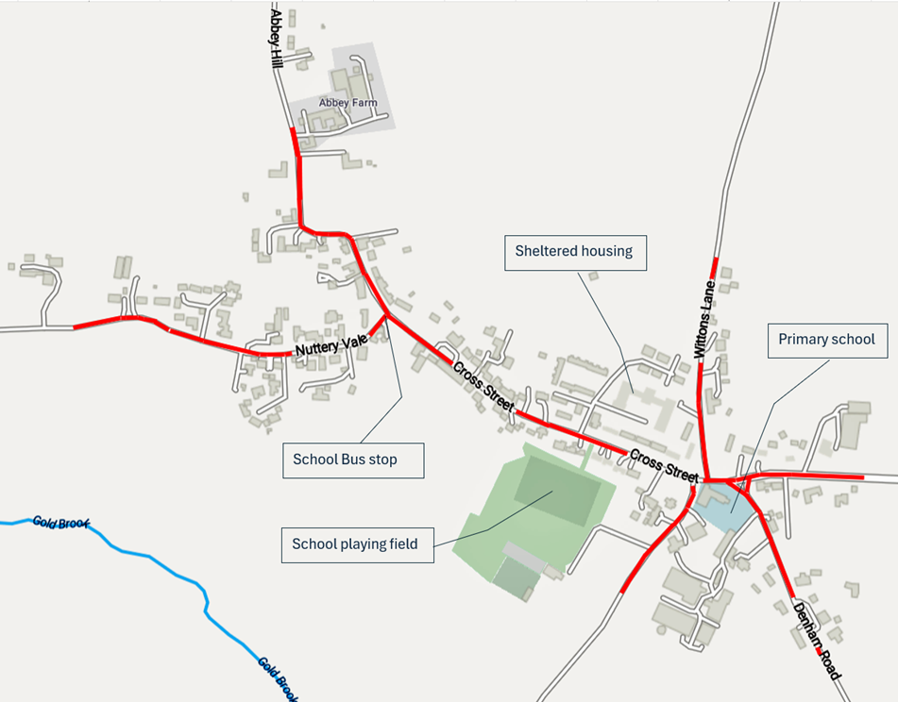

COLLISION DATA

Collision data has been sourced from an FOI request to Suffolk Constabulary covering the Hoxne Parish area and was received in July 2024. The recording by the police and on the attached Crashmap do not provide all collision data as their recording is incomplete for several years including 2024 and a subsequent map has been attached to complete the picture. Many collisions were not reported to the police and have also been included and all can be substantiated by witnesses from the parish.
The collisions occur across the parish but the most serious are generally situated on the B1118 along its whole length in Hoxne. Suffolk Constabulary have concluded that the area is not suitable for designation as a KSI site but by extending the 30 mph limit and introducing a buffer zone the potential for collisions should significantly be reduced. Enforcement by Suffolk Constabulary can then take place on suitable stretches of the road. The police and Suffolk Highways must work together in reducing casualties and collisions on this busy route.

CRASHMAP 2012 - 2022
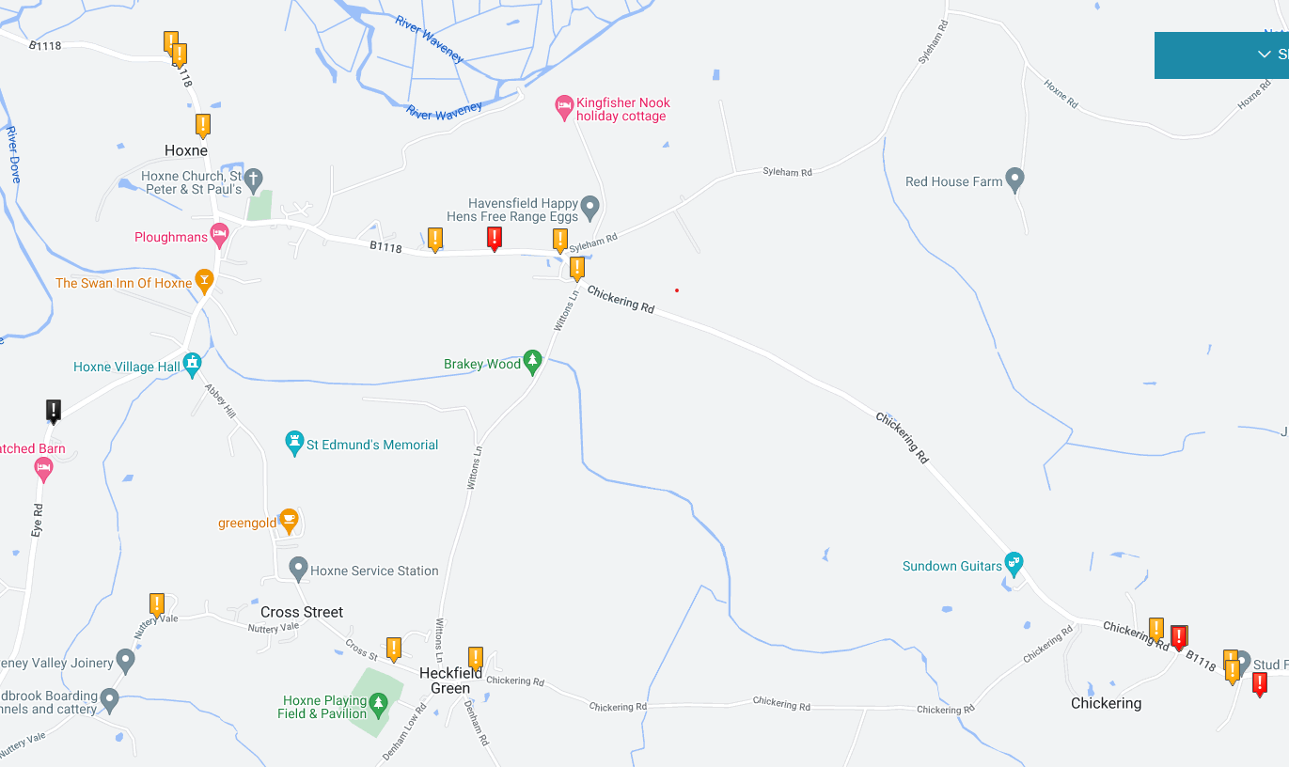

SUFFOLK CONSTABULARY FOI MAP 2012 -2024
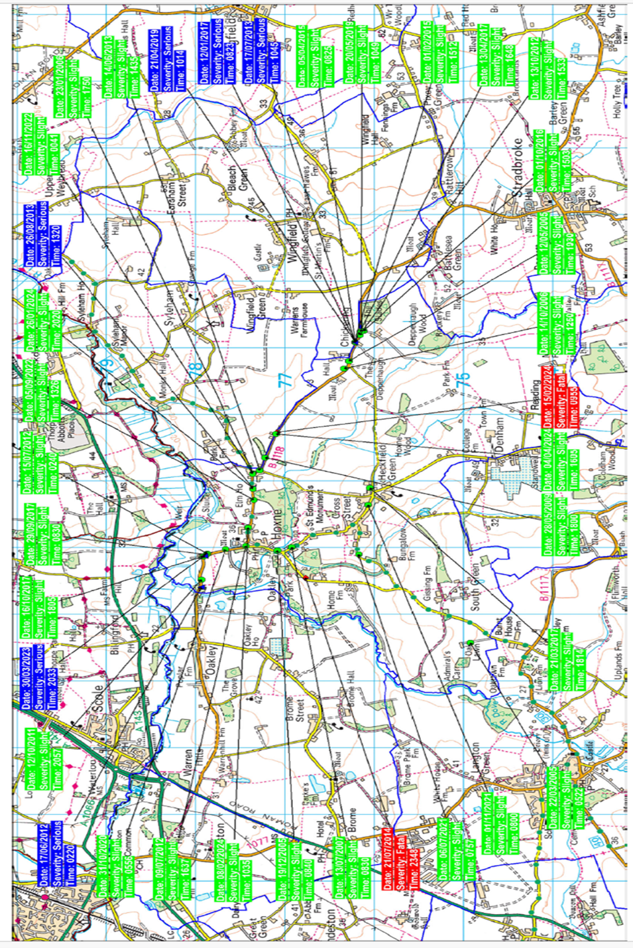

ADDITIONAL COLLISIONS 2024 NOT RECORDED - HOXNE PARISH COUNCIL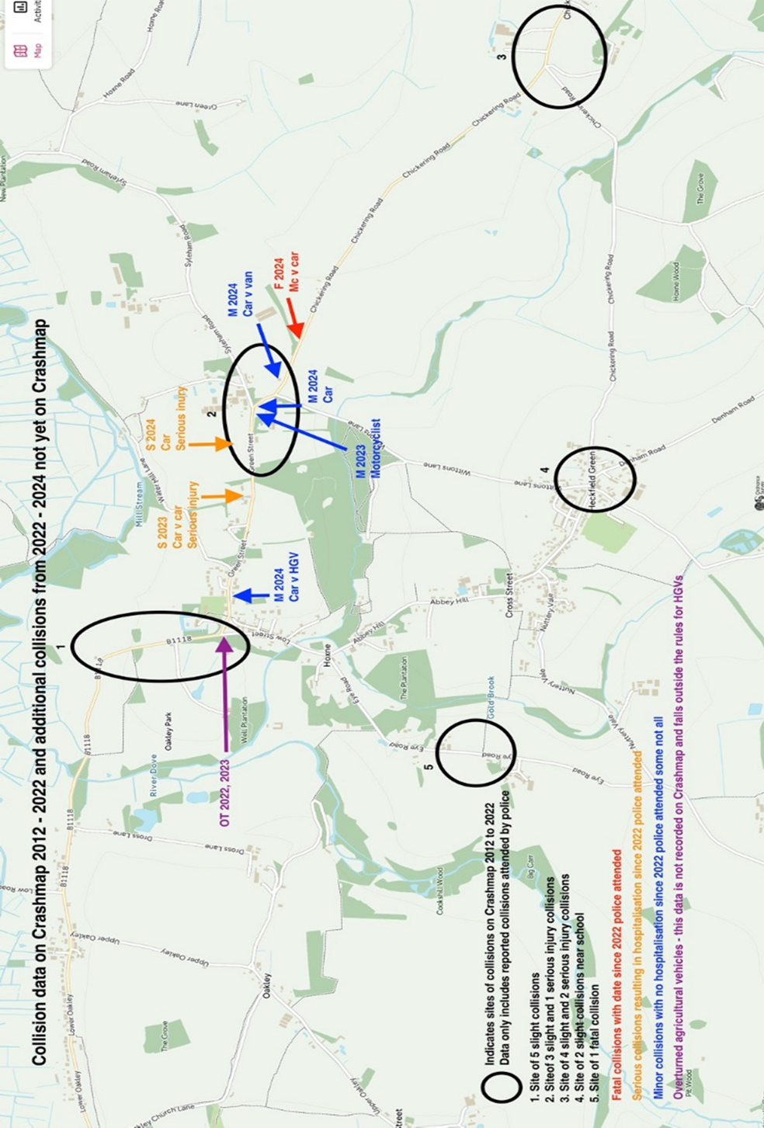
In addition to the data recorded on Crashmap and by Suffolk Constabulary above, further collisions must be noted that are not included.
Green Street at the bend towards Oakley
1.11.2017 – Overturned farm vehicle
Green Street junction with Low Street
25.8.2015 – Overturned large straw trailer
21.5.2021 – Overturned low Loader carrying earth movement equipment
Circa 2022 – Overturned slurry trailer
19.1.2023 – Overturned Car (going westbound)
Green Street near Moat House
24.11.2023 – Collision between two goods vans
Green Street junction with Wittons Lane
11.5.2024– Decamp RTC – Car crashed through hedge into front garden, driver decamped.
27.4.2024 – Single motorcycle collision slight injury

CONSULTATION PROCESS

In drawing up our proposal, we have consulted widely with individuals and key stakeholders including local transport firms, the village school, the church and the Depperhaugh Care Home.
Below are details of the measures taken:
- Publicised in Village Voice magazine, which is published every two months and distributed to every household in the village.
- Proposed changes have been on the Parish website since July 2024.
- Hosted a display stand at the Hoxne Annual Parish meeting, held in the Village Hall on 24.4.2024.
- Had a display at the Hoxne Mayfest event, held on the Playing Field at Heckfield Green on 4.5.2024.
- Had a display in the Village Shop from May 2024.
- Plan on display at the Greengold Café May 2024.
- Met with parents and staff at St Edmunds Primary School 20.6.2024.
- Plans shared with Vicar and Parish Parochial Council.
- Plans displayed at Depperhaugh Care Home for 2 weeks end June 2024.
- Residents at Chickering messaged individually July 2024.
- Held a meeting with a Crown Milling on 3.7.2024.

SUFFOLK CONSTABULARY EMAIL REGARDING SPEED WATCH

Good morning

My name is Guy Ainsworth. I am the current Speed Watch Manager for Suffolk Police.
Yesterday morning I did call and left a voice message on your answer system which may have
been a little garbled but it advised I was in the Hoxne area yesterday and would review consideration
For setting up a Speed Watch Scheme in Hoxne. This was after I had a request from Vicky McParland Chief Inspector to contact Sarah Foote
From the Parish council.
So I did have a good drive back and forth through the village a few times on a few roads including the main;

B1118 – Green St – Chickering Road:

Then Low St – Eye Rd :

Abbey Hill – Cross St :

Overal from driving about the area I can see you have a number of HGV passing through which I can see is not ideal
for the size of the village and roads.
From memory Vicky McParland mentioned some accidents, which from the sharp bends around the village I’m not surprised.
The bends are double edged. They can encourage to slow down but drivers speeding with eventually come unstuck
Especially in inclement weather. The bends also prohibited community speed operating near them as drivers will at times
Over compensate seeing someone in Hi-Viz pointing a speed gun at them, which also leads to accidents.
In regard to setting up a Speed Watch team – after driving the roads mentioned I could not find a safe suitable position
within our strict safety guidelines to set-up and monitor speeds which is a shame as even having Hi-Viz jackets on show
has an amazing effect on drivers’ behaviour.
Driving around the village I think I only saw 1 old “SID” device, is this something the council may increase.

Please feel free to call or email back if you wish to discuss further.
Many Regards
Guy
Guy Ainsworth
Constable
Communities Coordinator
Suffolk Constabulary

ADRIAN RAMSAY MP - SUPPORT EMAIL

Dear Sarah,

Adrian Ramsay MP says:

I am pleased to endorse Hoxne Parish Council’s Traffic Review Report which represents a well-considered and detailed investigation into traffic problems on the local road network. The Parish Council has been diligent in surveying the views of residents, identifying problems, gathering evidence and consulting the local community on their work. The report and its recommendations are the culmination of their impressive work. Inappropriate speeds through Hoxne blight the lives of everyone living there and detract from the attractive village scene. Pedestrians and cyclist are at particular risk from fast-moving vehicles. Fear and intimidation felt by vulnerable road users from speeding vehicles act as a deterrent to walking and cycling, which we need to be encouraging to improve public health and cut carbon emissions. Lower traffic speeds on selected village roads and improved signage and road markings will help to reduce road danger and the risk of accidents all round. I hope that Suffolk County Council will endorse the report which will lead to a better quality of life for everyone in Hoxne as well as for people travelling through.



Denise Carlo
Caseworker
Office of Adrian Ramsay MP
Waveney Valley

